DNS over HTTPS (DoH)

🔐 What is DNS over HTTPS (DoH)?
# Source: Chatgpt (GPT-5-Mini) at [1/18/2026]
DNS over HTTPS (DoH) is a security protocol that sends DNS queries and responses encrypted over HTTPS instead of plain text.
🧠 Traditional DNS is not encrypted, meaning your DNS queries can be seen, tracked, or modified by attackers or ISPs.
DoH fixes this by protecting your DNS traffic using the same encryption used for secure websites (HTTPS).

🧭 Why DoH Matters
# Source: Chatgpt (GPT-5-Mini) at [1/18/2026]
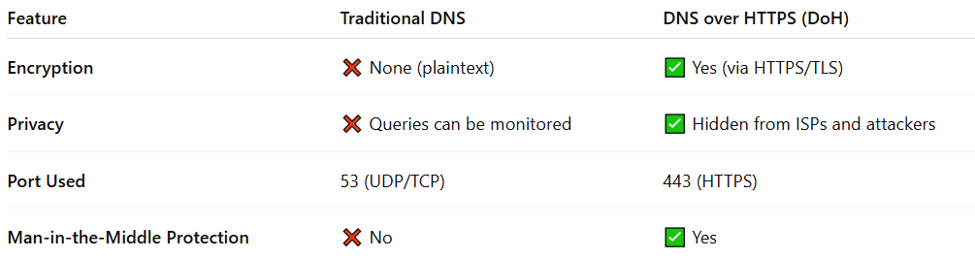

Feature | Traditional DNS | DNS over HTTPS (DoH)
Encryption | ❌ None (plaintext) | ✅ Yes (via HTTPS/TLS)
Privacy | ❌ Queries can be monitored | ✅ Hidden from ISPs and attackers
Port Used | 53 (UDP/TCP) | 443 (HTTPS)
Man-in-the-Middle Protection | ❌ No | ✅ Yes

🔐 How It Works
# Source: Chatgpt (GPT-5-Mini) at [1/18/2026]
- You type example.com in your browser.
- Instead of sending a plain DNS query to your ISP’s server, your browser/app:
  - Sends a DoH request over HTTPS to a trusted DoH server (like Cloudflare or Google).
- The server resolves the domain and replies over the same encrypted HTTPS connection.

🌐 Supported Browsers & Services
# Source: Chatgpt (GPT-5-Mini) at [1/18/2026]
- Browsers with DoH support: Firefox, Chrome, Edge, Brave, Safari (partially)
- DoH Providers:
  - Google: https://dns.google/dns-query
  - Cloudflare: https://cloudflare-dns.com/dns-query
  - Quad9: https://dns.quad9.net/dns-query

✅ Pros of DoH
# Source: Chatgpt (GPT-5-Mini) at [1/18/2026]
- ✅ Privacy: Keeps DNS queries hidden from ISPs and attackers.
- ✅ Security: Prevents tampering or spoofing of DNS queries.
- ✅ Bypasses censorship: Harder to block or filter domains.

⚠️ Potential Concerns
# Source: Chatgpt (GPT-5-Mini) at [1/18/2026]
- ❗ Can centralize DNS traffic to a few big providers.
- ❗ Might bypass local parental controls or enterprise filters if not configured carefully.

✅ Summary
# Source: Chatgpt (GPT-5-Mini) at [1/18/2026]


Feature | Description
DoH | Encrypts DNS using HTTPS
Port | 443 (HTTPS)
Main Benefit | Privacy and protection against eavesdropping
Used by | Browsers, mobile apps, some OS settings

